**Project Design Phase-I Solution Architecture**

|  |  |
| --- | --- |
| Date | 19 September 2022 |
| Team ID | PNT2022TMID17544 |
| Project Name | Plasma Donor Application |
| Maximum Marks | 4 Marks |

**Solution Architecture:**

* Software Required:
  + Python, Flask , Docker
* System Required:
  + 8GB RAM,Intel Core i3,OS-Windows/Linux/MAC ,Laptop or Desktop
* During the COVID 19 crisis, the requirement of plasma became a high priority and the donor count has become low. Saving the donor information and helping the needy by notifying the current donors list, would be a helping hand. In regard to the problem faced, an application is to be built which would take the donor details, store them and inform them upon a request.
* In other words, there is a requirement for new infrastructure to facilitate donors, blood banks and hospitals for easier donation and access of blood plasma that could potentially satisfy the excess demand for it to be used for treatment
* **Technical Architecture:**

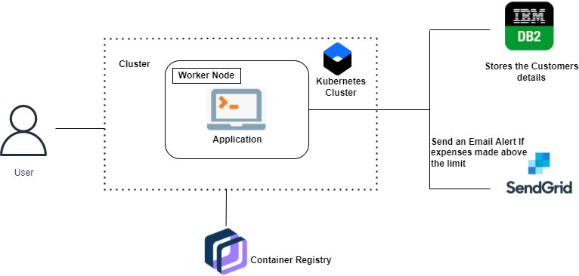

**Example - Solution Architecture Diagram:**

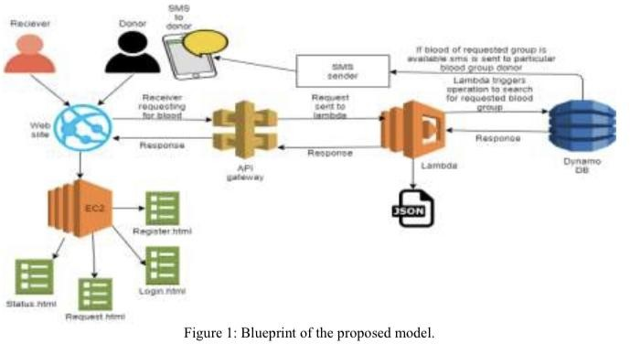

**Reference:**

[**https://aws.amazon.com/blogs/industries/voice-applications-in-clinical-research-powered-by-ai-on-a**](https://aws.amazon.com/blogs/industries/voice-applications-in-clinical-research-powered-by-ai-on-aws-part-1-architecture-and-design-considerations/)[**ws-part-1-architecture-and-design-considerations/**](https://aws.amazon.com/blogs/industries/voice-applications-in-clinical-research-powered-by-ai-on-aws-part-1-architecture-and-design-considerations/)